**Paper title in English**

**Paper title in Serbian**

**Science field (i.e. Subject) title**

**ABSTRACT**

**Introduction:**

**The Aim:**

**Material and Methods:**

**Results:**

**Conclusion:**

**Keywords:**

**SAŽETAK**

**Uvod:**

**Cilj rada:**

**Materijal i metode:**

**Rezultati:**

**Zaključak:**

**Ključne reči:**

**Introduction**

The introduction should start at the top of the first page of the paper text itself (not in the continuation of the previous page). It should contain literature data on the problem that is addressed in the paper. The review of known facts mustn’t be too long, however, it must clearly justify the reason why the research presented in the paper was undertaken in the first place.

The basic hypotheses and the goal of the paper should also be stated here.

**Material and Methods**

***Subheadings (if desired – they can, but do not have to be used)***

*Sub-subheadings (if necessary)*

Describe in detail and with accuracy the conducted observation and experiment. In the case of a human population, state the number, age, gender and other characteristics of the respondents (e.g. explain why only persons of a certain age were included or why women were excluded). Define exactly what the description means and point out how the data was obtained (e.g. what was the interval of control tests or examinations, whether you obtained the data by yourself or received the data from someone else, etc.). In the case of experimental animals, state the species, number, age, sex and other characteristics of the animals used.

State the names of the methods used in the research as well as the exact name of the apparatus (model, manufacturer). When stating the name of the drug, use generic names, and in parentheses state the registered name of the drug. In addition to the name of the drug, state the dosage and method of application.

In the case of randomized clinical projects, present information on all major elements of the study, including the protocol (study population, interventions, outcome and explanations of statistical analyzes), intervention specification (randomization method, concealment, treatment group divisions), etc.

Describe the statistical methods used during the processing of the results. Specify the generally accepted computer program used (if licensed).

**Results**

***Subheadings (if desired – they can, but do not have to be used)***

*Sub-subheadings (if necessary)*

Present the results in a logical order. In parentheses state the number of attachments (e.g. Attachment I), which explains the results in more detail. If the attachment contains multiple subparts, it is possible to adress each segment specifically in the text – e.g. Attachment IIA.

**Discussion**

The discussion represents a detailed analysis of the comparison between obtained results and previously published, known results. Avoid making claims and conclusions that are not fully supported by the results. Describe whether the findings differ from the results of other researchers. Offer an alternative explanation of the results taking into account the suggestions of the mentor / co-author. Avoid generalizations that are not supported by the data. Do not suggest solutions to problems that are not directly related to your research. Clearly indicate whether the hypotheses set in the introduction (i.e. goal) of the paper are confirmed or refuted by the obtained results. Describe the limitations of the research conducted.

**Conclusion**

The conclusion contains the main message of the paper, i.e. summarizes the key elements presented in the discussion.

**Literature**

1. Kallestinova ED. How to write your first research paper. Yale J Biol Med. 2011; 84(3):181-90.
2. Choi H, Uceda DE, Dey AK, Abdelrahman KM, Aksentijevich M, Rodante JA, et al. Treatment of Psoriasis with Biologic Therapy Is Associated with Improvement of Coronary Artery Plaque Lipid-Rich Necrotic Core: Results from a Prospective, Observational Study. Circ Cardiovasc Imaging. 2020; 13:e011199.
3. Fauci AS, Braunwald E, Kasper DL, Hauser SL, Longo DL, Jameson JL, et al., editors. Harrison’s Principles of Internal Medicine. 17th ed. New York: McGraw Hill; 2008.
4. Partridge H, Hallam G. Evidence-based practice and information literacy. In: Lipu S, Williamson K, Lloyd A. editors. Exploring methods in information literacy research. Wagga Wagga, Australia: Centre for Information Studies; 2007. p.149–170.
5. All About Adult BMI. Centers for Disease Control and Prevention. [cited 14 March 2022]. Available from: https://www.cdc.gov/healthyweight/assessing/bmi/adult_bmi/index.html.

**ATTACHMENT I**

**Table 1.** Detailed and clear table description from which it will be unambiguously clear to the readers what is presented on it (the example below is illustrative and in no case represents the form that must be followed)

|  |  |  |  |
| --- | --- | --- | --- |
| Column 1 | Column 2 | Column 3 | … |
| Row 1 |  |  |  |
| Row 2 |  |  |  |
| … |  |  |  |

**Legend:** If necessary (if you need to explain certain elements in detail, list the abbreviations used, etc.)

**ATTACHMENT II**



**Graph 1.** Detailed and clear description of the graph with all of its elements (the example above is illustrative and in no way represents the form that must be followed). If multiple graphs represent parts of a whole or the same problem, it is possible to present them together as a single attachment, with different letters indicating different parts of the attachment (A, B, C, etc.). In the graph description specify the meaning of each graph segment. Make sure to correctly label graph axis!

**Legend:** If necessary (if you need to explain certain elements in detail, list the abbreviations used, etc.

**ATTACHMENT III**

**A**

**B**

**Picture 1.** Detailed and clear description of the pictures used, with mandatory source statement (in the form of a number of the reference stated in the Literature segment), if the picture is not an original work made by the author. If multiple pictures represent parts of a whole or the same problem, it is possible to present them together as a single attachment, with different letters indicating different parts of the attachment (A, B, C, etc.). In the picture description specify the meaning of each segment.

**Legend:** If necessary (if you need to explain certain elements in detail, list the abbreviations used, etc.)

**ATTACHMENT IV**

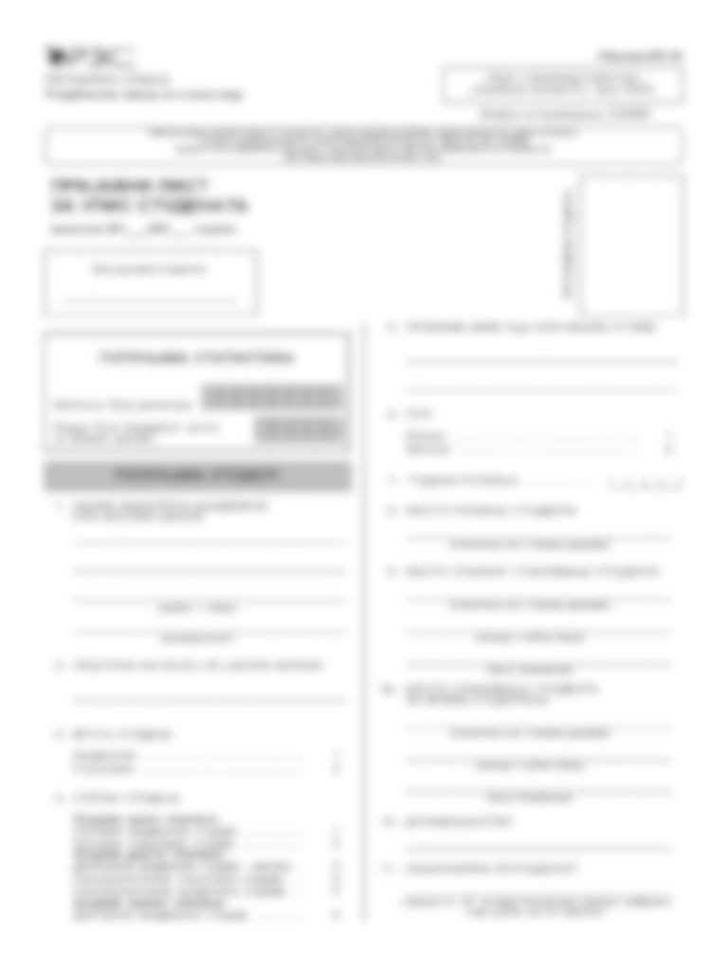**Questionnaire 1.** Present a questionnaire with a brief and clear desctiption

**Legend:** If necessary (if you need to explain certain elements in detail, list the abbreviations used, etc.)